Name:
People of History
PERSON | MOST KNOWN FOR: | TWO INTERESTING ACTIONS/IMPACTS: | LASTING INFLUENCE:
MOHANDAS GANDHI

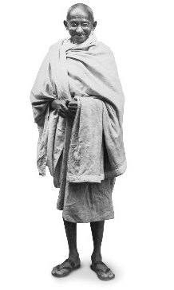

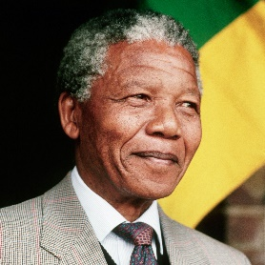
NELSON MANDELA

PERSON | MOST KNOWN FOR: | TWO INTERESTING ACTIONS/IMPACTS: | LASTING INFLUENCE:
POL POT
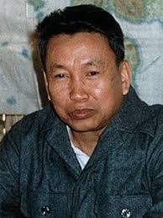

DENG XIAOPING

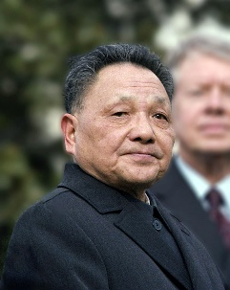

PERSON | MOST KNOWN FOR: | TWO INTERESTING ACTIONS/IMPACTS: | LASTING INFLUENCE:
AUNG SAN SUU KYI

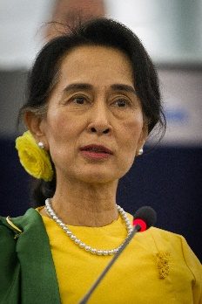
MIKHAIL GORBACHEV

